SAGNIK BASU 113EC0199

**QUESTION**

### **Communication Channel Equalizer using Perceptron**

Design a perceptron/ adaline with suitable activation function for communication channel equalization as detailed in the accompanying document.

**MATLAB CODE**

clc;

clear all;

close all;

c=input('Channel order');

experiments =50.0;

samples=1000;

x=2*rand(1,samples)-1;

inp=zeros(1,samples);

for i=1:length(x) %%generation of inputs

if(x(i)<0)

inp(i)=-1;

else if(x(i)>0)

inp(i)=1;

else

inp(i)=0;

end

end

end

%noise=2*rand(1,samples)-1; %%noise(bias)

%%channel 1

%y1=inp+noise;

SNR=20;

y1=awgn(inp,SNR);

weights=2*(rand(1,c))-1;

bias=2*rand(1,1)-1; %%bias for the perceptron

y=zeros(1,samples);

output=zeros(1,samples);

error=zeros(1,samples);

err_train=zeros(1,samples);

%%final_err_train=0;

for j=1:samples-c

%% input1(:,j)=input(:,r);

y(1,j)=y1(1,j:j+c-1)*(transpose(weights))+bias;

%%out(1,j) = (1/(1+exp(-y(1,j))));

%%e=d_out(r)-out(j);

output(1,j)=hardlims(y(1,j));

%MSE Calculation for 50 experiments

final_err_mse2=0;

for k=1:experiments

y_mse2(1,k)=y1(1,k:k+c-1)*(transpose(weights))+bias;

output_mse2(1,k)=hardlims(y(1,k));

error_mse2(1,k)=inp(1,k)-output(1,k);

final_err_mse2=final_err_mse2+error_mse2(1,k)*error_mse2(1,k);

end

mse_2(j)=final_err_mse2/experiments;

%%training

error(1,j)=inp(1,j)-output(1,j);

%%err_train(j)=error(1,j)*error(1,j);

bias=bias+error(1,j);

weights=weights+error(1,j)*y1(1,k:k+c-1);

weights_array(j,:)=weights;

%%weights_final(j,:,k)= weights;

%%bias_final(j,1,k) = bias;

%%error(j,1,k) = e;

end

%%Testing

testing_size=1000;

y_test=2*rand(1,testing_size)-1;

input=zeros(1,50);

final_err=0;

mse=zeros(1,50);

SNR=1;

for k=1:100

y_test=2*rand(1,testing_size)-1;

input=zeros(1,testing_size);

for i=1:length(y_test) %%generation of inputs

if(y_test(i)<0)

input(i)=-1;

else if(y_test(i)>0)

input(i)=1;

else

input(i)=0;

end

end

end

final_err=0;

SNR_arr(k)=SNR+k/10;

y1=awgn(input,SNR_arr(k));

BER=0;

for i=1:testing_size-c+1

y1_test(1,i)=y1(1,i:i+c-1)*(transpose(weights))+bias;

percp_out(1,i)=hardlims(y1_test(1,i));

error_test(i)=percp_out(1,i)-input(1,i);

if(error_test(i)==0)

else

BER=BER+1;

end

%final_err=final_err+error_test(i)*error_test(i);

BER_arr(k)=BER/1000;

end

%mse(k)=final_err/1000.0;

end

%axis([-3 3 -3 3]);

%w1=-bias/weights(1,1);

%w2=-bias/weights(1,2);

%plot([w1,0],[0,w2]);

%hold on;

%plotpv(inp,inp);

%hold on;

%plotpc(weights,bias);

**FIGURES (MSE Plot and BER Plot)**

**1) Channel Order =4**

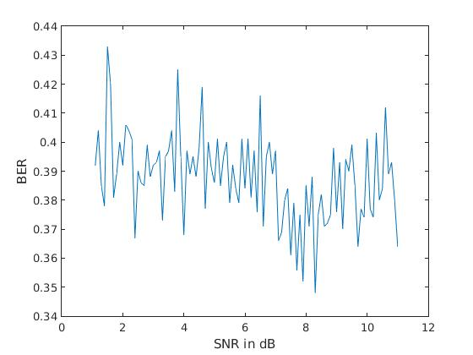

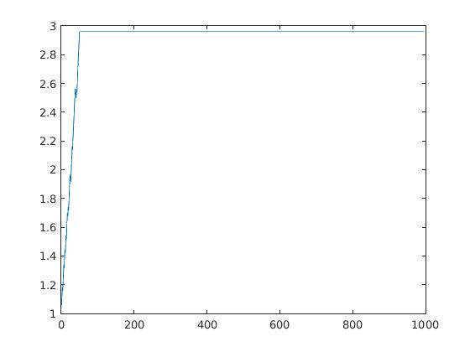

**Channel Order =3**

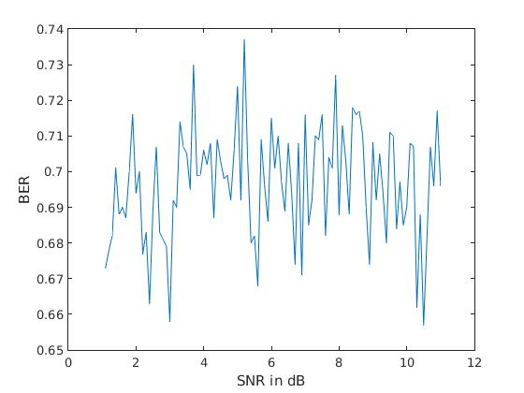

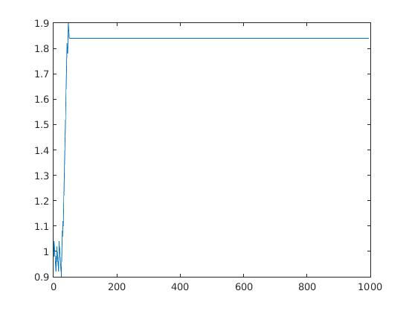

**3)Channel Order =2**

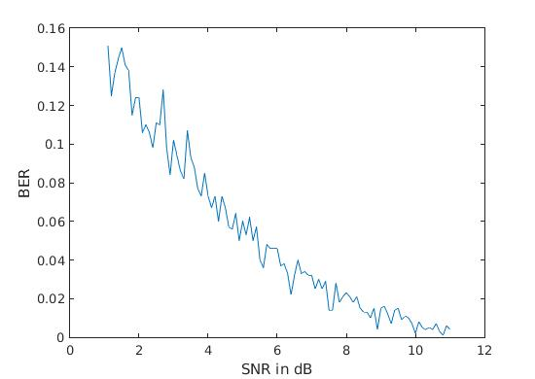

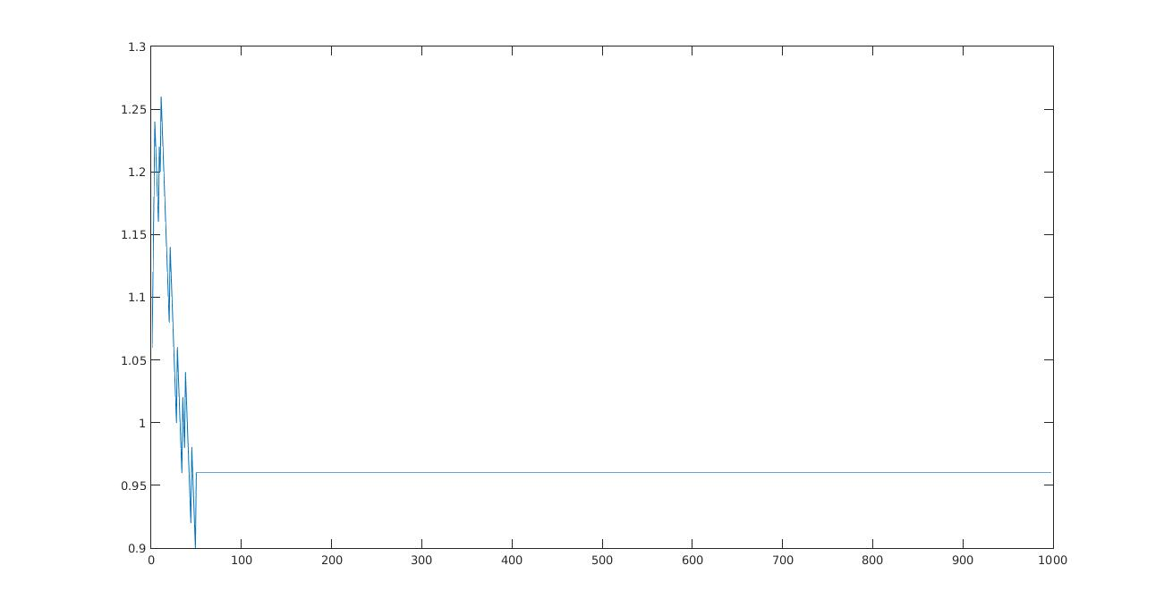

**Decision Boundary for various SNR**

**1) SNR = 5 Db**

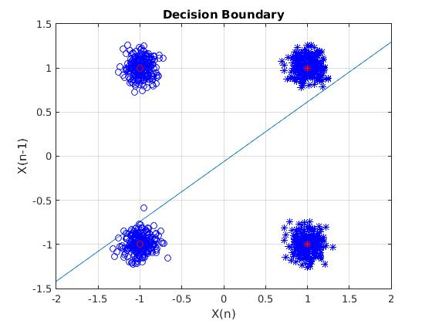

**2) SNR =10 Db**

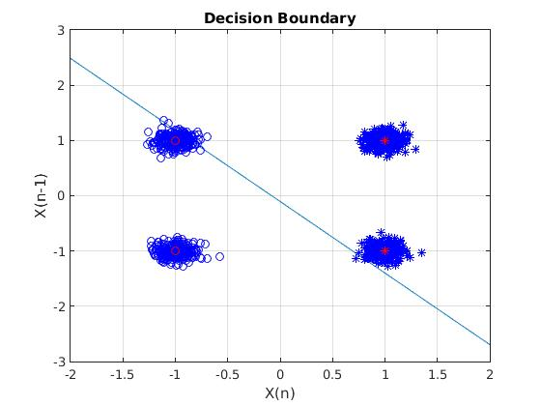

**3)SNR = 15 Db**

